**PL/SQL Exercise-3 Stored Procedures : by Sahil Singh**

 Accounts Table :

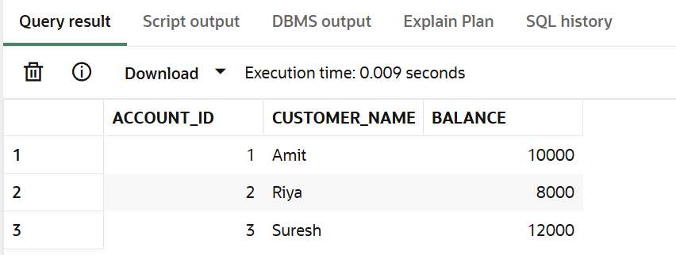

Employees Table :

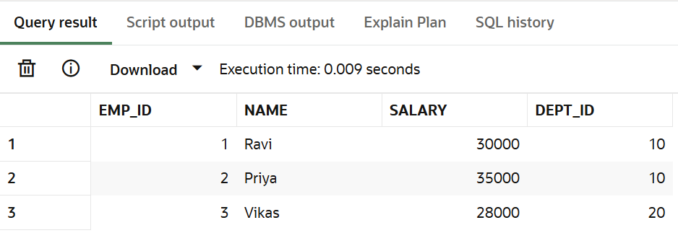

## Scenario 1: Monthly Interest for Savings Accounts

The bank needs to process monthly interest for all savings accounts.

Procedure Name: ProcessMonthlyInterest

Apply 1% interest to the current balance of all customers’ savings accounts.

CREATE OR REPLACE PROCEDURE ProcessMonthlyInterest AS

BEGIN

  FOR acc IN (SELECT Account_ID, Balance FROM Accounts) LOOP

    UPDATE Accounts

    SET Balance = Balance + (acc.Balance * 0.01)

    WHERE Account_ID = acc.Account_ID;

  END LOOP;

END;

/

BEGIN

  ProcessMonthlyInterest;

END;

/

Output:

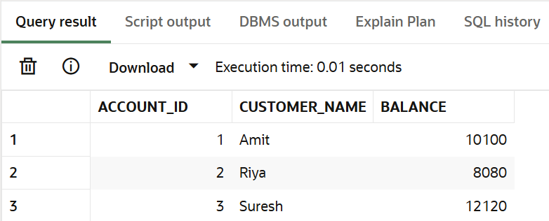



## Scenario 2: Performance Bonus for Employees

implement a bonus scheme for employees based on performance. Procedure Name: UpdateEmployeeBonus Add bonus percentage (passed as parameter) to employee salary in a particular department.

CREATE OR REPLACE PROCEDURE UpdateEmployeeBonus(

  dept_id IN NUMBER,

  bonus_percent IN NUMBER

) AS

BEGIN

  UPDATE Employees

  SET Salary = Salary + (Salary * bonus_percent / 100)

  WHERE Dept_ID = dept_id;

END;

/

BEGIN

  UpdateEmployeeBonus(10, 10);

END;

/

Output:

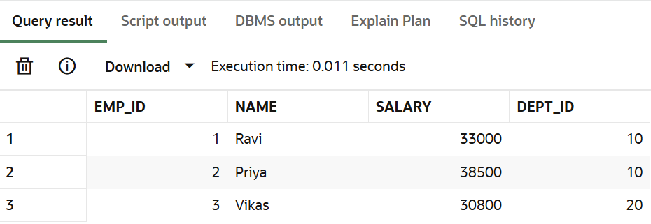



## Scenario 3: Transfer Funds Between Accounts

Customers should be able to transfer funds between their accounts.

Procedure Name: TransferFunds Transfer a specified amount from one account to another only if source account has enough balance.

CREATE OR REPLACE PROCEDURE TransferFunds(

  from_acc IN NUMBER,

  to_acc IN NUMBER,

  amount IN NUMBER

) AS

  from_balance NUMBER;

BEGIN

  SELECT Balance INTO from_balance FROM Accounts WHERE Account_ID = from_acc;

  IF from_balance < amount THEN

    DBMS_OUTPUT.PUT_LINE('Insufficient funds.');

  ELSE

    UPDATE Accounts SET Balance = Balance - amount WHERE Account_ID = from_acc;

    UPDATE Accounts SET Balance = Balance + amount WHERE Account_ID = to_acc;

    DBMS_OUTPUT.PUT_LINE('Transfer successful.');

  END IF;

END;

/

BEGIN

  TransferFunds(1, 2, 2000);

END;

/

Output:

